Exercise

Value Stream Map Data Box
Read the scenario below and determine the data for data boxes in the VSM of the payroll process.
TJ was leading a Lean Six Sigma project to improve the process that creates the company payroll. The primary complaint was that numerous errors were occurring in the payroll. In some cases, people were not receiving the correct salary. In other cases, incorrect deductions were applied. This was causing complaints throughout the workforce. A further problem was that nearly 75% of the time, the process took so long that Finance personnel were working until midnight the day before the payroll was due to ensure that it was created on-time.
TJ had created the flow of the value stream as it is shown below. It was then time to setup the data boxes and collect the data.
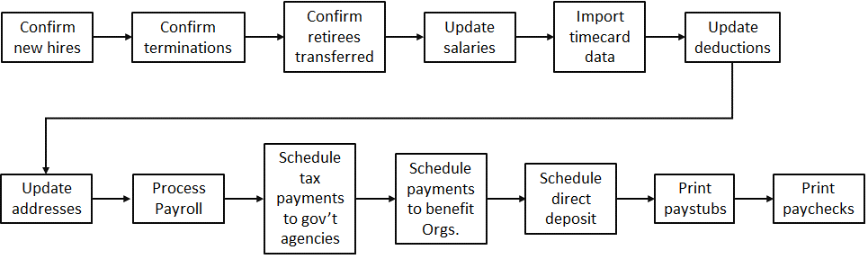
Fortunately, most of the steps were done using one of the business systems and there were time stamps for the process steps. Also, HR and Finance had a record of every paycheck that needed to be corrected and the type of correction, so TJ could determine which steps were creating the most errors. He was also able to get from HR and Finance the number of people they had working on each of the steps.
TJ pulled data from the last three months and averaged it. The data is in the table below.
Step | Total step time | Error Rate | # HR people | # Fin People | # People in Other Depts
Confirm new hires | 137 min | 0.03% | 1
Confirm terminations | 8 min | 0% | 1
Confirm retirees & transfers | 1,047 min | 0.05% | 2
Update salaries | 2,803 min | 0.02% | 1
Import timecard data | 4,338 min | 4.61% |  |  | 21
Update deductions | 245 min | 0.07% | 1
Update addresses | 1,395 min | 0.28% | 2
Process payroll | 42 min | 0% |  | 1
Schedule tax payments | 87 min | 0% |  | 1
Schedule benefits payments | 226 min | 0.33% |  | 3
Schedule direct deposit | 121 min | 0.28% |  | 1
Print paystubs | 151 min | 0.17% |  | 2
Print paper paychecks | 1,194 min | 0.28% |  | 2

While TJ had total time for each step, he did not have the value-added time for each step. TJ and his team met with HR and Finance and watched them as they completed each step of the process. Based upon that review, TJ set the value-added time for each step:
Step | Batch Size per payroll run | Step Unit | Value- Added Time | Comments
Confirm new hires | 11 people | person |  | QC check
Confirm terminations | 8 people | person |  | QC check
Confirm retirees & transfers | 27 people | person |  | QC check
Update salaries | 148 people | person | 39 sec | Go to screen, enter data
Import timecard data | 2,733 people | person |  | Just moving data
Update deductions | 102 people | person | 27 sec | Go to screen, enter data
Update addresses | 41 people | person | 49 sec | Go to screen, enter data
Process payroll | 1 payroll | payroll | 12 min | Run the program
Schedule tax payments | 14 Gov’t agencies | Govt Agency | 4 min | Complete online
Schedule benefits payments | 26 organizations | Benefit Org | 3 min | Complete online
Schedule direct deposit | 51 banks | bank | 71 sec | Complete online
Print paystubs | 3,821 people | person | 1 sec | Printer
Print paper paychecks | 383 people | person | 2 sec | Printer

Create data boxes for the payroll process and place the data in the data boxes.

