Solution

Creating a New Document
Your Preset options should look like this:
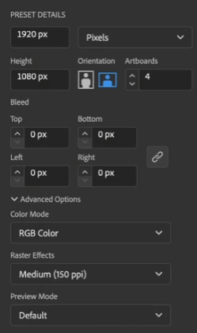
After you click ‘Create’, you should have your document set up with a custom name and four 1920x1080 artboards. You will notice in the gray tab in the upper left hand corner of your document that you can also see the name of your file. Here it should say ‘RGB’ indicating that you are in the RGB Color Mode.

Exercise notes
- While there are preset templates available for print, web, etc. on the Home screen, we want to create our own document from scratch.
- You can leave the ‘Bleed’ settings set to ‘0’ since bleed is typically used for print documents.
- It’s important to make sure that you are working in RGB instead of CMYK as the CMYK color space is also used for print documents.

