Exercise

Product Lifecycle
A product has a lifecycle that provides monthly sales and profits of:
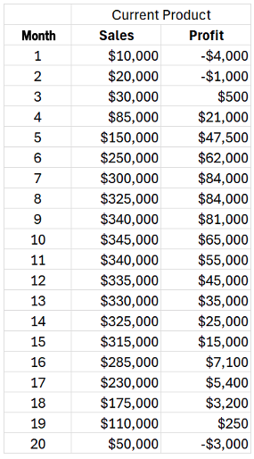
Assume a new product will have similar sales and profits and that the new product development project takes 9 months.
- What is the latest month the project need to start so that the combined sales of this existing product and the new product exceed $300,000 per month. Assume the lifecycle sales of the new product are the same as the existing product.
(Determine when the new product must launch so that the combined monthly sales stay above $300,000. Based on that launch date, the project must start nine months earlier to complete at the desired time.)

- If the new product is launched so as to keep sales above $300,000 per month, what is the lowest level of combined profits, and in which month does that occur.

