Solution

Introducing Copilot - Your Helpful AI Assistant
​The tech world has been 'buzzing' about AI for quite some time. Applications like Chat GPT have grabbed the headlines as a quick way to generate content, answer questions and take the hard work out of mundane tasks.
With any new technology, particularly AI, some people will embrace it whilst others are more wary. Talk of AI taking people's jobs and making certain roles obsolete are valid concerns.
Microsoft showed their commitment to AI tools by purchasing Open AI, the owners of Chat GPT and releasing their own tool, Copilot late last year.
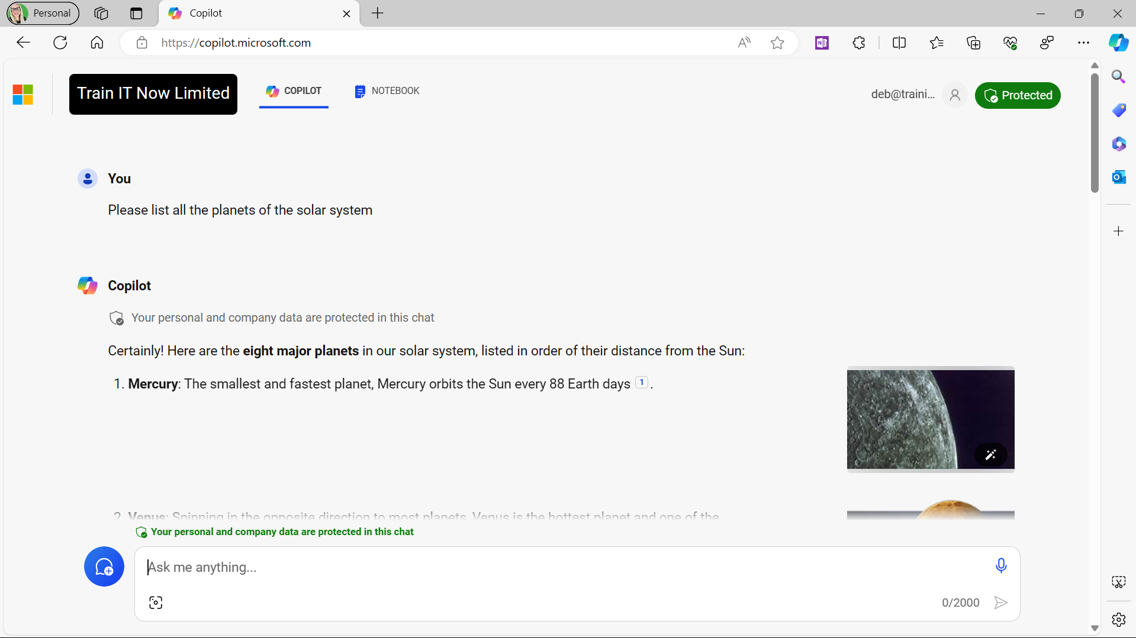​
Upon the initial release of Copilot, it was only available to large organizations of 300 users or more at a cost of $30 per month, per license.
Fortunately, Microsoft were quick to react to the backlash and relaunched Copilot to accommodate small and medium sized organizations as well as general Microsoft 365 users. This new offering was to sit alongside the FREE version of Copilot that's accessible to all, Copilot for Bing.
Now we have three offerings: Copilot, Copilot Pro, and Copilot for Microsoft 365 applications.

Hints & tips
- Copilot for Microsoft 365 applications is available to small, medium and large organizations and Microsoft 365 users for an additional monthly fee. For more information, go to Copilot for Microsoft 365.

