Solution

Create a Presentation

Create a Presentation with Copilot and Designer
- Open PowerPoint.
- From the File tab, click New.
- Select Blank presentation.
- Open Copilot.
- Type the prompt: ‘Create a presentation about the process of making candles at home. The presentation should be at least 10 slides long’.

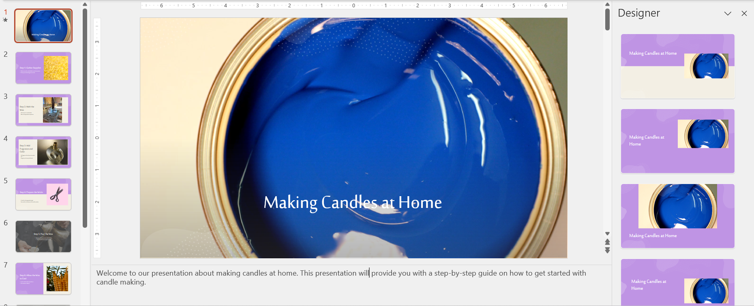
- From the Home tab, click the Designer button.
- Switch out the layouts for other designs.

Delete Slides
- Type the prompt ‘Delete slide 10 from the presentation’.

​

