Solution

Draft Documents

Create a New Document
- Open Word.
- From the File tab, click New.
- Click Blank Presentation.

Create a Draft with Copilot
- Click the Copilot tag on the page or press Alt+I.
- The Draft with Copilot box will open.
- Type the prompt: ‘Write me an introduction for a children's book about friendly monsters that live at the bottom of the garden’.
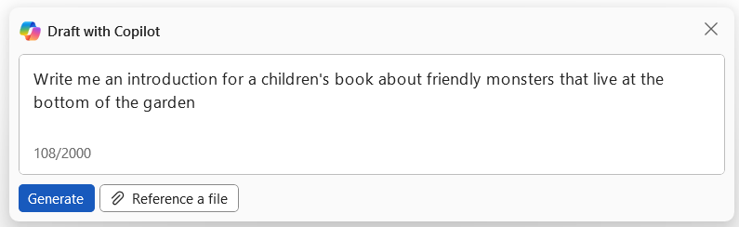
- Click Generate.
- Type ‘Make the introduction longer’ into the prompt box.
- Click the arrow to regenerate.
- Type ‘Make the tone more appropriate for young children’’ into the prompt box.
- Click the arrow to regenerate.
- Click Keep it.

The Copilot Pane
- Open the Copilot Pane.
- Type the prompt: ‘Summarize this document’.
- Copy (CTRL+C) the summary and paste (CTRL+V) it into the top of the document.
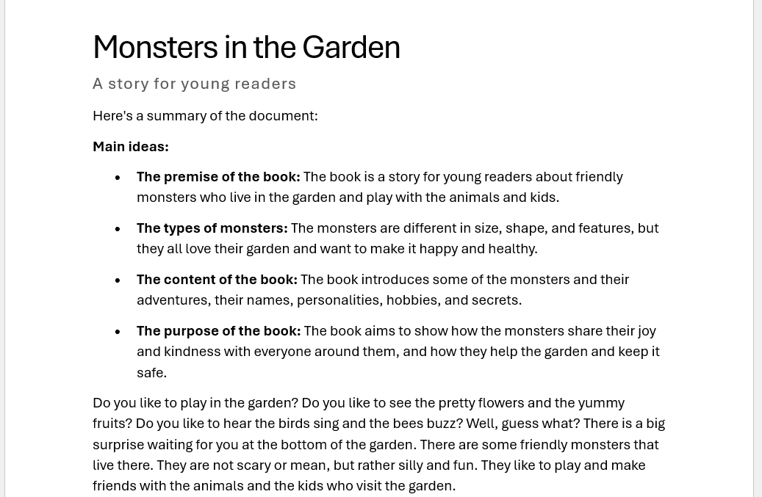

Hints & tips
- Use the keyboard shortcut ALT+I to open the Draft with Copilot box.
​

