Solution

Income Statements
- Navigate to the profit and loss statement.
The statement should look similar to what you saw in our lesson. The exact design and layout will vary depending on the financial software you use.
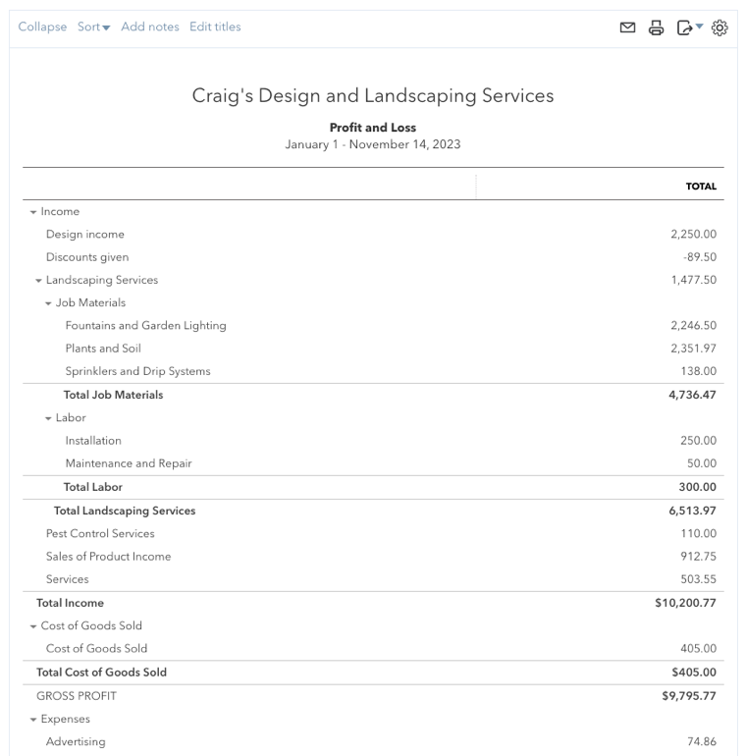
This is a report that is referenced a lot in business and it’s important to know how to find it.

- What are the three sections of an income statement?
Income, Cost of Goods Sold, and Expenses.
If you're using a report such as the FreshBooks income statement, income and cost of goods sold may be combined into one section.

- Look for the checking account.
There is no checking account on an Income Statement, but it would appear on a Balance Sheet.

