Exercise

Significance of the Income Statement
Let’s continue to look at Income Statements. Here’s the example from our lesson:
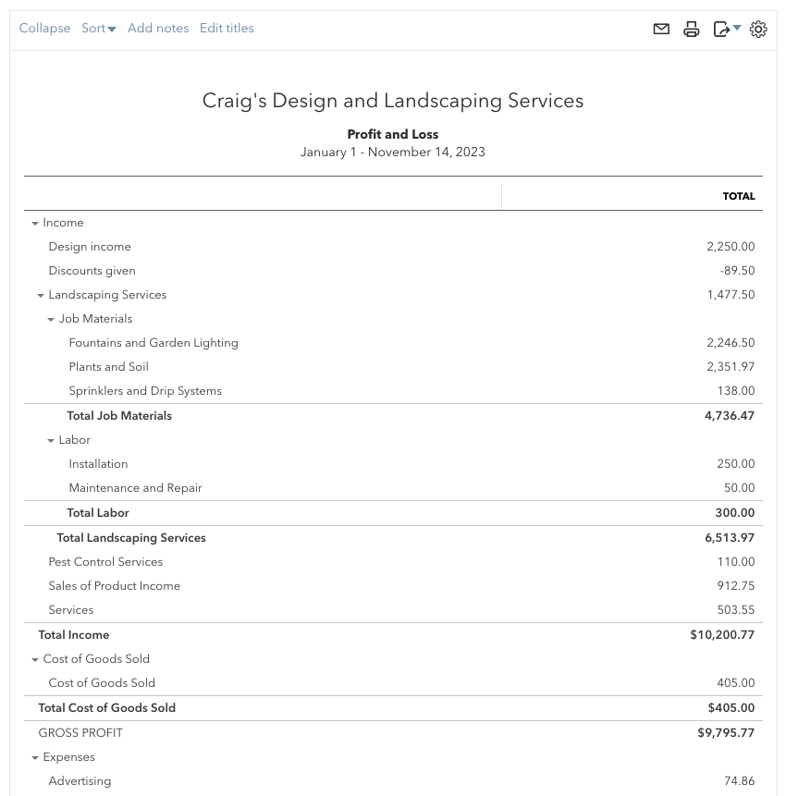

You can also view the QuickBooks Online demo file from our lessons at the following link: https://qbo.intuit.com/redir/testdrive

- You can see multiple accounts listed below Income, including ‘Design income’ and ‘Landscaping services’ (which has its own sub-accounts). Why are these accounts important? Why is it helpful to view them on this statement?
- Using the online demo file, choose an expense account and click on its dollar amount on the right-hand side for that account. What do you see?

