Solution

Introduction to Access 2021

Download the course and exercise files to an easily accessible folder.
- Download and open the completed version of the database ‘TechGurusTicketing_Completed_Database.accdb’.
- From the Navigation Pane on the left, in the Forms group, double-click on ‘frmTicketMaintenance’.
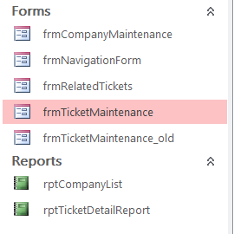
- Review the completed version of the database.

