Solution

Add a Likert Scale Question

Add a Likert Scale Question
- Open the form ‘Apex Gym Members Survey’.
- Click Add New.
- Click the drop-down arrow to open up more options and choose Likert.
- Type the question ‘How satisfied are you with the following services at Apex Gym’.
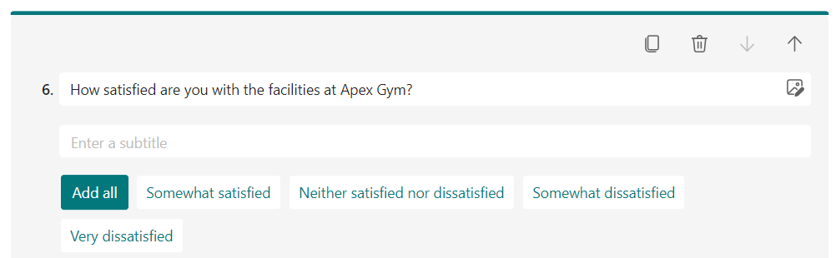
- Click in Option 1 and type: ‘Highly Satisfied’
- Click in Option 2 and type: ‘Very Satisfied’
- Click in Option 3 and type: ‘Satisfied’
- Click in Option 4 and type: ‘Not Satisfied’
- Click in Option 5 and type: ‘Highly Unsatisfied’
Now we can add in our statements.
- Click in Statement 1 and type: ‘Swimming Pool’
- Click in Statement 2 and type: ‘Classes’
- Click in Statement 3 and type: ‘Gym Floor’
- Click in Statement 4 and type: ‘Weights Area’
- Click in Statement 5 and type: ‘Gym Cafe’
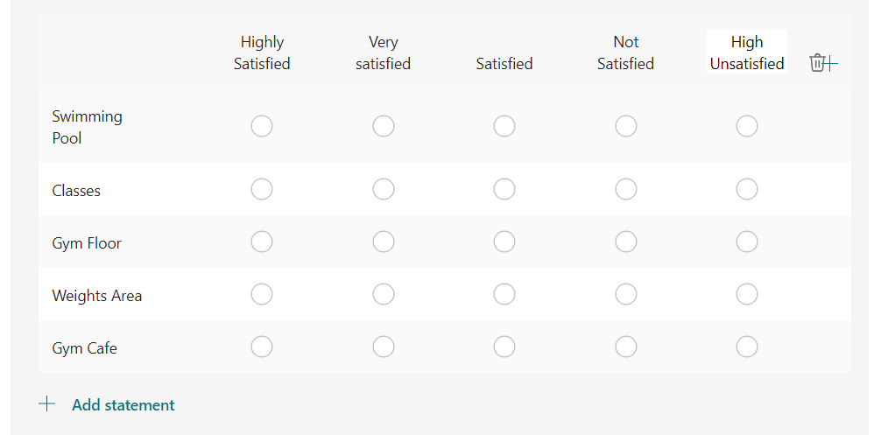​

Preview the Form
- Click the Preview button to preview the form.
​