Exercise

Contact Groups aka Distribution Lists
Follow along with the video and practice creating a new Contact Group using your existing Outlook People (Contacts) section.
- Open your contacts view by clicking the People button.
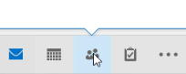 OR 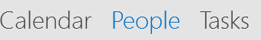
- Click New Contact Group.
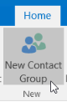
- Name the group and click Add Members.
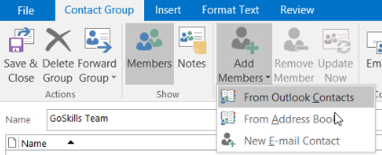
- Select and double-click the names to be added to the group.
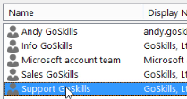
- If you need to remove someone, open the group and select Remove Member.
