Solution

# Create a Team and Add Members

## Create a Team

### Create a public team from scratch

1. Click **Join or create a team**.



1. Click **Create team**.
2. Choose **From scratch**.

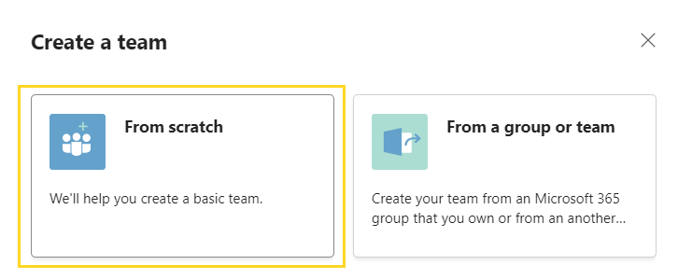

1. Click **Public**.
2. Type a name for the team '*Contoso Limited*'.
3. Add a **Description** (optional).
4. Click **Create**.

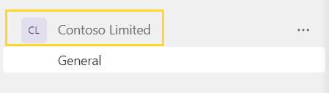

## Add Members

1. Click the **three dots**, next to ‘Contoso Limited’.
2. Click **Add members**.
3. Type the name of the team members to add.
4. Click **Add**.

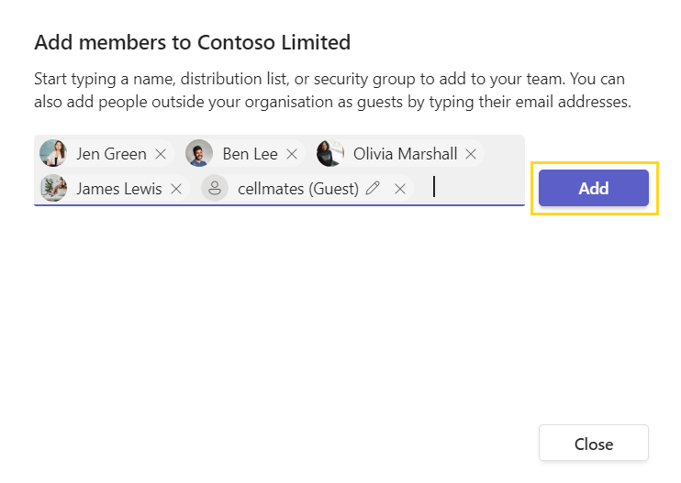

## Exercise notes

* If you are adding yourself or family members, type the full email address and add them as guests.