Solution

Creating a title slide – Part 1

Creating a Slide Background

Add a background image
- Click the File tab and then New.
- Select Blank Presentation.
- From the Design tab, in the Themes group, apply the Gallery theme.
- Ensure you have downloaded the background image ‘Zen-background.jpg’ from the exercise and saved it to the desktop or a folder of your choice.
- From the Insert tab, in the Images group, select Picture.
- Choose From Device from the list.
- Browse to the folder where the image is saved.
- Select the image and click Insert.
- From the Picture Format tab, in the Size group, select the lower half of the Crop button.
- Choose Fill.
- Drag the black handles out to fill the surrounding space.
- Choose Fill again.
- Click Crop.

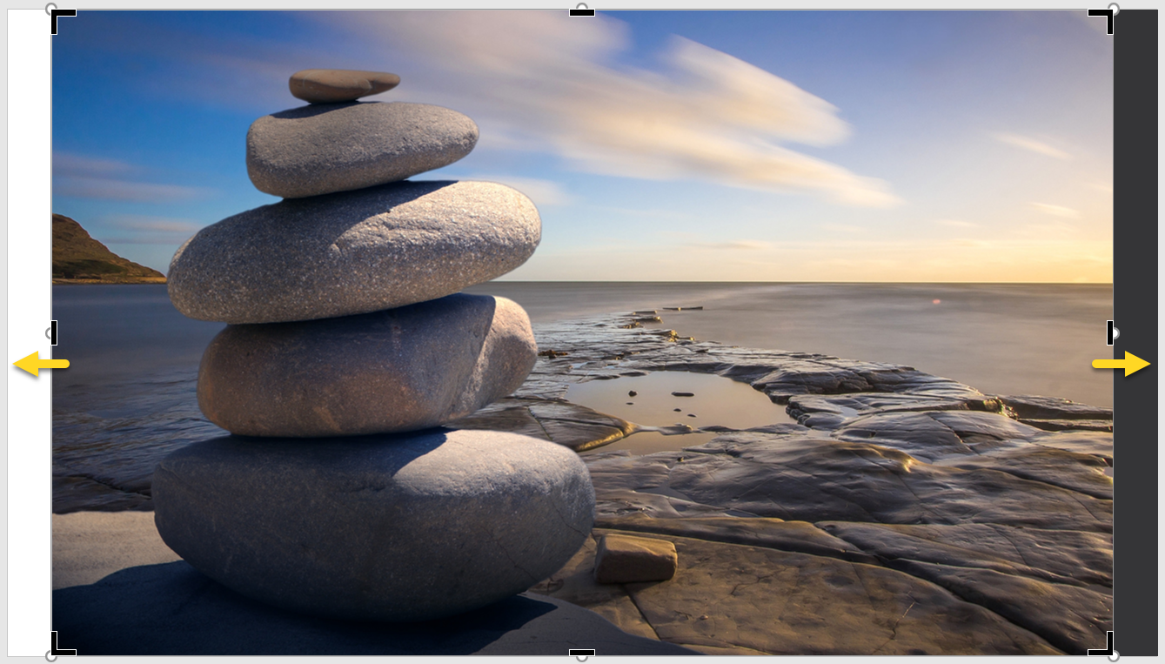

Use Shapes and Transparencies
- From the Insert tab, in the Illustrations group, click Shapes.
- Choose the rectangle shape from the gallery.
- Draw a rectangle over the image so it covers it.
- From the Shape Format tab, in the Shape Styles group, click Shape Fill.
- Choose ‘Indigo, Accent 5, Darker 50%’ from the palette.
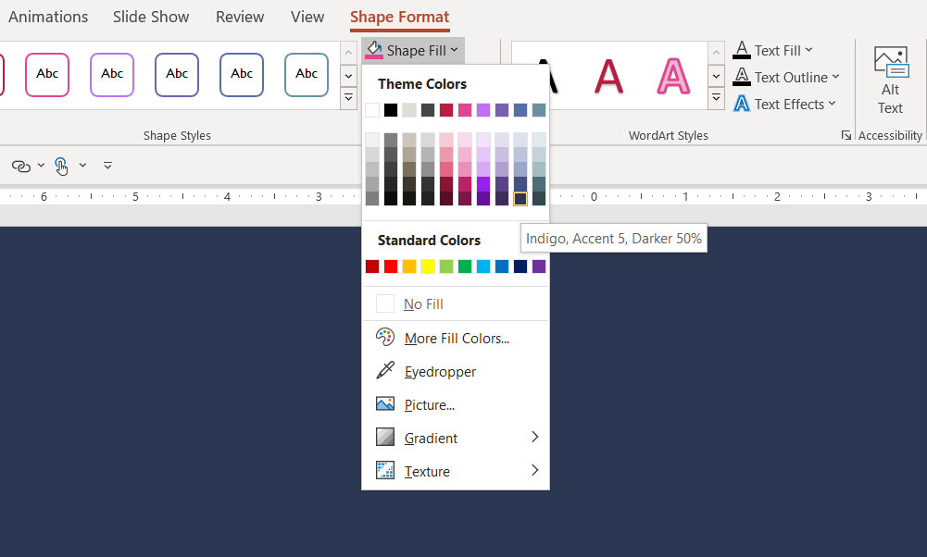

- Right-click on the shape and select Format Shape from the contextual menu.
- From Shape Options, in the Fill section, change the transparency to 22%.

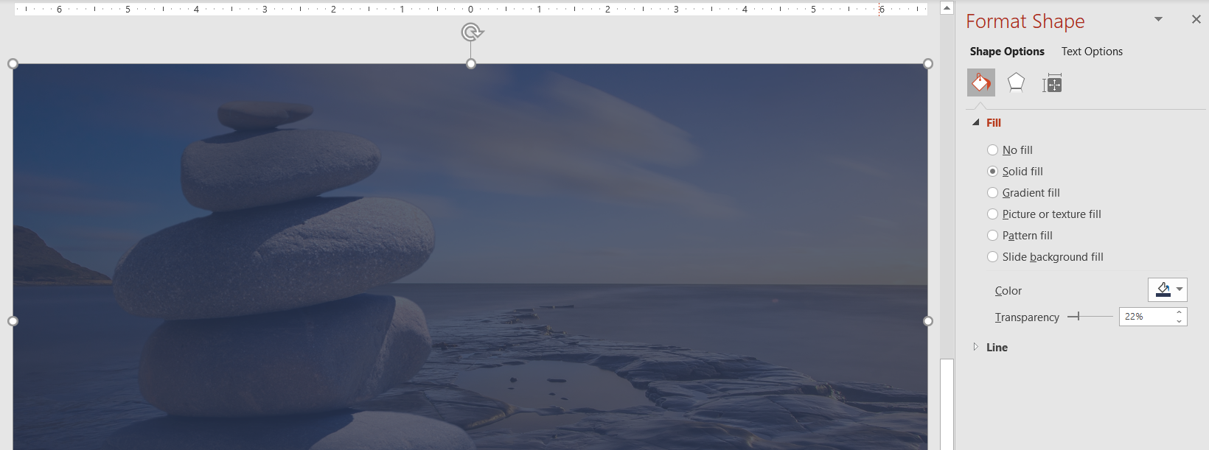

Save the Presentation.
- Click the File tab.
- Select Save As.
- Click Browse.
- Navigate to a folder of your choice.
- Name the file ‘The Zen Den – your initials’.
- Check the Save as type is set to .pptx.
- Click Save.

