Solution

Introduction to Todoist

Welcome to the Todoist GoSkills course
This course will be guiding you through Todoist. Todoist is one of the most popular task management platforms for teams and professionals to organize their tasks and get things done.
Solution: Install Todoist
The Todoist app can be installed on most devices. This makes it very accessible for adding tasks across your work day. These are your options to install Todoist:
- Web (via browser)
- Desktop (MacOS, Windows, Windows 7/XP)
- Android
- iPhone & iPad
- Android Wear
- Apple Watch
- Google Chrome Browser
- Firefox Browser
- Safari Browser
- Email Plugin: Outlook & Gmail

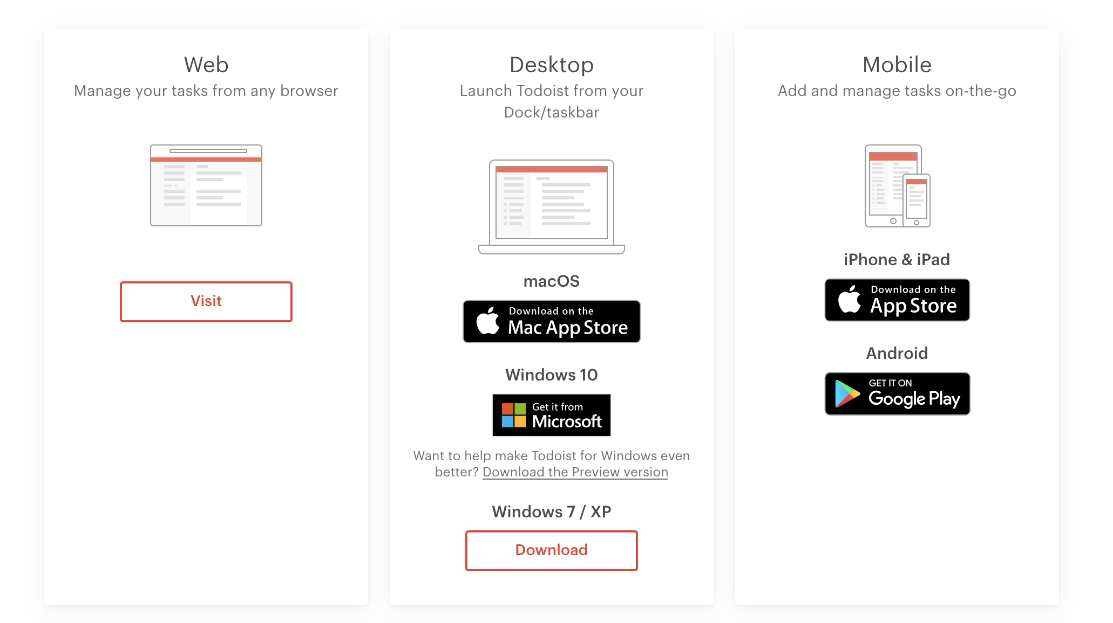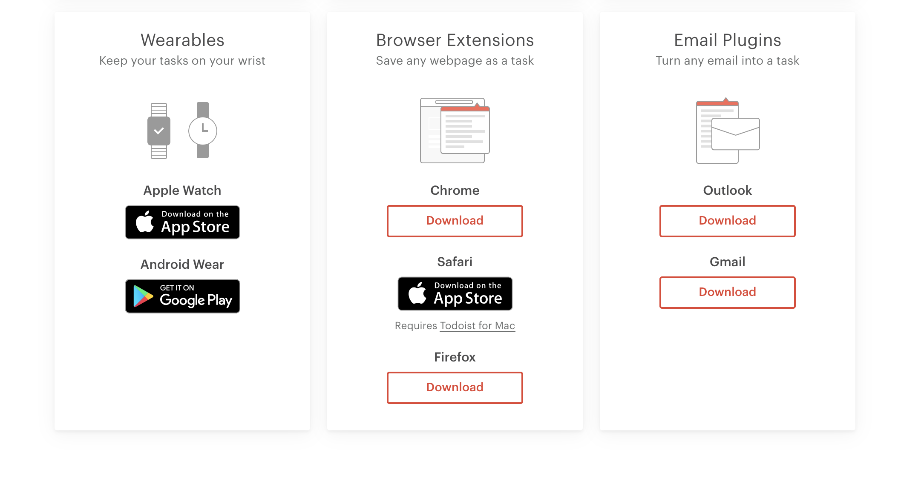

Remember to:
- Only use Google login with secure Google account
- Take care with your sign-in details, remember and secure them

