Solution

# Add Formula Columns

Open the exercise file ‘02-03 Sales Data Exercise-Start.xlsx’.

* Open Copilot.

## Add a Total Sales Column

* Type the prompt: *'Calculate the Total Sales by adding the ‘Revenue’ and ‘Profit’ columns’.*
* Press **Enter**.

Copilot will start to generate formula column suggestions.

* Scroll up to see the details, and the syntax of the formula.
* Click **Insert column**.

## Add 20% Sales Tax

* Type the prompt: ‘*Calculate the total sales with 20% sales tax added*’.
* Click **Insert column.**

## Add a Total Row

* Type the prompt: ‘*Add a total row to the table*’.
* Manually set the ‘Product’ column to show the count.
* Manually set the ‘Quantity’, ‘Price per item’, Revenue’ and ‘Profit’ columns to show the sum.

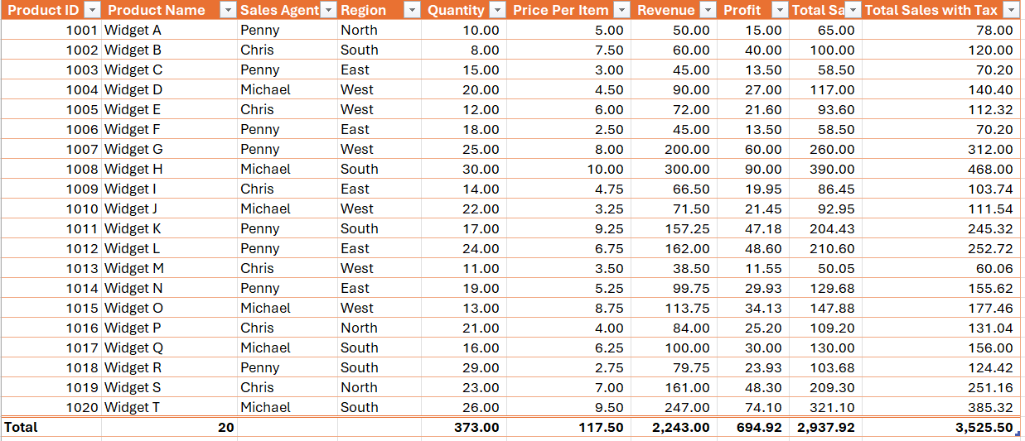​

# Hints & tips

* Formula results can be previewed by hovering our mouseover Insert column. This will show a preview of the column. Click to add the column permanently.
* Use **CTRL+down arrow** to jump to the bottom of a dataset and **CTRL+up arrow** to jump to the top of a dataset.

​

## Exercise notes