Solution

Overview of the Teams Dashboard

Get familiar with the Teams Dashboard

Open Teams
- Double-click on the Teams icon on your desktop OR search for it on your PC.
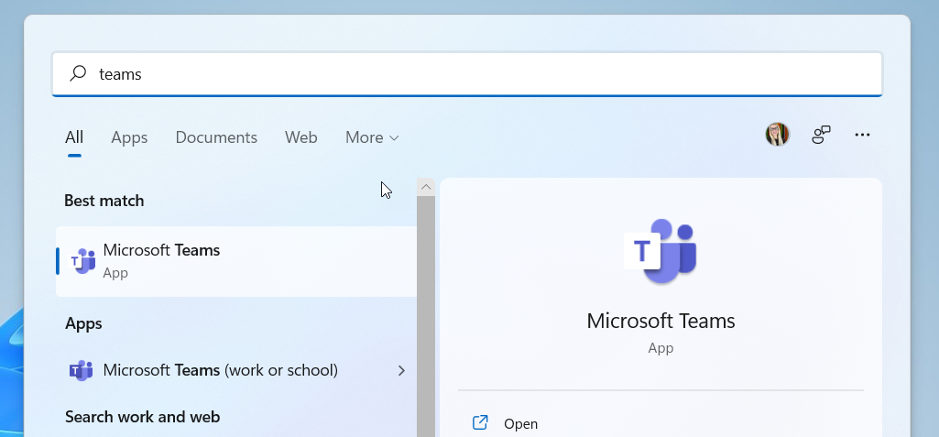
- Alternatively, log into your Microsoft 365 account.
- Click on the App Launcher.
- Click Teams.
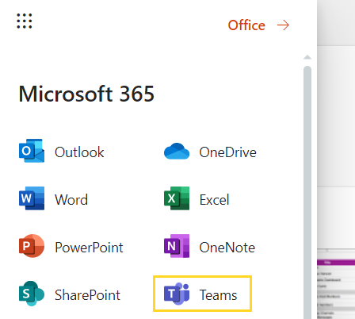

Review the Teams Dashboard
- Click on every button in the Teams navigation menu and get familiar with where to go to view the activity feed, create a new team, upload files, install apps etc.
